Урок английского языка   
7 класс  
на тему:  
“I go to school”



Провела учитель английского языка

МКОУ «Урахинская СОШ»

Алишихова Мариям Исаевна

**Цель урока:** формирование компетенции в чтении, аудировании, устной речи и в письме.

**Задачи:**

учебные: активизировать в речи введенную ранее лексику по теме, совершенствовать грамматические навыки (the Present Progressive **Tense:** утвердительные, отрицательные и вопросительные предложения), практиковать в монологической и диалогической речи, чтении;

развивающие: формировать познавательные умения, задавать вопросы и отвечать на них, развивать мыслительные навыки, логическое и образное мышление;

воспитательные: воспитывать любовь к родной школе, классу, чувство взаимопомощи, желания общаться на английском языке.

**Тип урока:** закрепление знаний по теме.

Наглядные пособия: Интерактивная доска, раздаточный материал, карточки, рабочие листы.

Ход урока:

Организационно –мотивационный этап.

T. Good morning children!

I, m glad to see you!

Sit down, please.

Are you ready for the lesson?

P. Yes, we are ready.

T. I am glad to hear it.

Let’s start our lesson.

**2. Этап формулирования темы урока.**

So, today we will revise the words that you have learnt during your previous lessons.

We will practice our vocabulary, listening, writing, speaking , and reading skills.

Now children look at there slider and try to guess what we are going to talk about today. **(Приложение)**

T. Have you got any ideas?

Now we are going to speak about school.

When I was a school girl I liked school very much and you? Do you like your school?

P. Yes.

T. Ok. Thank you.

**3.Phonetic activities.**

T. Now look at the screen. Today we begin our lesson with the poem. I read line by line and you repeat it after me.

Our school is best of all,

With green flowers and clean walls,

With the windows which are wide,

and the pupils who are bright.

w i: ju ai

**4. Listening**

**Этап развития навыков аудирования.**

Listen to the text and complete the sentences.

Прослушайте текст и выберите правильный вариант ответа.

Занесите результат в таблицу.

1. The girl, s name is……….

**a)** pat **b)** Cat **c)** Mat **d)** Bat

2. She is ……..

**a)** 8 **b)** 9 **c)** 7 **d)** 10

3. Desks and chairs are ……

4. The blackboard is ……..

**a)** on the wall **b)** on the floor **c)** on the ceiling **d)** under the carpet

5. There are a lot of …….

**a)** pictures **b)** photos **c)** magnets **d)** posters on the blackboard

6. The teacher’s table is near the …….

**a)** door **b)** window **c)** wall **d)** blackboard

7. You can see ……

**a)** books and exercise books **b)** pens and pencils **c)** rulers **d)** erasers on the teacher’s table

8. It, s time for …..

**a)** the lesson **b)** a break **c)** going home **d)** watching TV

|  |  |  |  |  |  |  |  |
| --- | --- | --- | --- | --- | --- | --- | --- |
| **1** | **2** | **3** | **4** | **5** | **6** | **7** | **8** |
|  |  |  |  |  |  |  |  |

**5.Reading.**

**Этап развития навыков чтения.**

Read the text and match the statements Tue – (T),

False - (F) - .

Read the text and mark each sentence after it ‘’T ‘’ for true , ‘’F ‘’ for false ‘’ NS ‘’ for not stated .

Children do a lot of things at school . A the Russion lessons they learn to read and to write . At the Math lessons they learn to count and do sums. At the Drawing lessons they learn to draw and colour pictures . At the Music lessons they sing songs . At the P.E. lessons they run and jump and play different games . At the English lessons they learn to write English letters ,read English and speak English School is fun .

1 . Children learn Russian , Math , Music and many other subjects at school. 2 . Children learn to do sums at the Drawing lessons.

3. At the Music lessons children learn to sing well .

4. At the P . E . lessons children usually run and jump .

5. Children learn to speak and write English at school .

6. School is dull .

|  |  |  |  |  |  |
| --- | --- | --- | --- | --- | --- |
| 1 | 2 | 3 | 4 | 5 | 6 |
|  |  |  |  |  |  |

**6. Relaxion.**

**Физкультминутка**

**(Приложение)**

**7. Vocabulary practice.**

Lets divide into groups and revise our vocabulary.

1. **Blackboard** – классная доска.

**classroom** – классная комната.

**come** - приходить, приезжать.

**Plant** – растение

**put** – класть

**tape recorder** - магнитофон

**video recorder** - видеомагнитофон

**windowsill** – подоконнчик

**write** – писать

**open** – открывать

**Close** – закрывать

**know** – знать

**take** – брать

**say** – сказать

**spell** – писать

**today** –сегодня

**understand** – понимать

**8. Grammar activities….**

***Подчеркните нужную форму глагола***

***1. I (“am”, “is”, “are”) going to the Zoo now.***

***2. Nick (gets /get ) up at 7.***

***3. They (“am”, “is”, “are”) walking in the park now.***

***4. The children (play / plays) football here every day.***

***5. The children (“am”, “is”, “are”) running at the stadium.***

***Поставьте предложения в вопросительную и отрицательную формы:***

1. We are discussing a difficult problem now.

2. I am learning a funny poem now.

3. The pupils are having history lesson.

4. Lis is sweeping the floor now.

5. He is playing computer games.

***Переделайте предложения в Present Progressive Tense:***

1. I open the door.

2. The cat sleeps on the bed.

3. The boys write the letters.

4. We sing songs.

5. He plays chess.

***Cоставьте предложения из данных слов:***

1. Now, a literature lesson, we, having, are.

2. A child, sleeping, in the bedroom, now, is.

3. Isn’t, now, he, a story, reading.

4. Are, drinking, they, milk?

5. Volleyball, my friends, playing, in the garden, are

**9. Speaking.**

**Этап развития навыков говорения.**

You must work in pairs.

Put the sentences in the logical order and then act it out.

Vika: Yes, I am. I am a pupil of the fourth form.

Sasha: What time do you go to school?

Vika: I have six lessons every day.

Sasha: Vika, are you a pupil?

Vika: I go to school at nine o, clock every day.

Sasha: How many lessons do you have every day?

**10. Этап развития навыков монологической речи**

Is big your school?

Do you like your school?

How many lessons do you in a day?

How many times in a week do have English?

Is your classroom big and nice?

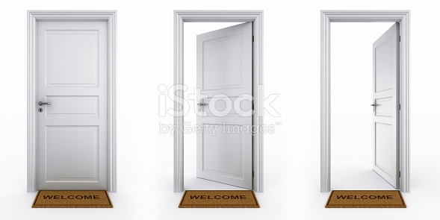My name is ……..

I m a pupil ……

I m in the 6 th ……

In my classroom there, s ____ ____ and ____

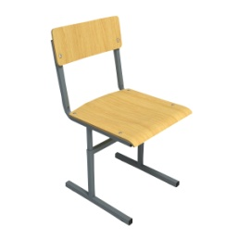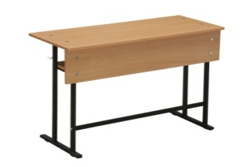There are ____ ___ and _____ ____



for ____ children ______. There are ______

and ________ / .

.

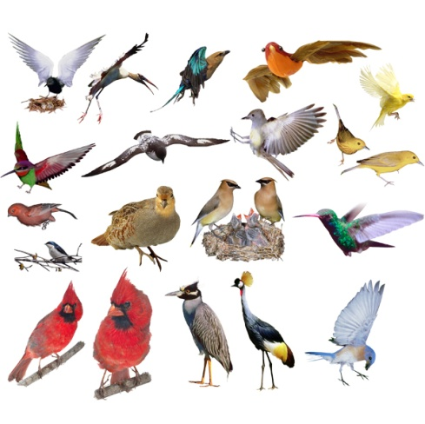

There are some _ on the walls.



There is a in front of the

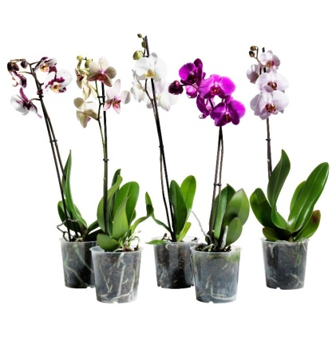desks.

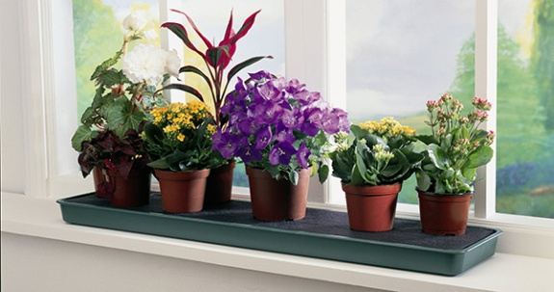

There are some on the

My classroom is big and nice.

**10. Home - Task.**

**Этап объяснения домашенего задания**

Write – about your school. (проект)

**11. Conclusion.**

**Заключительный этап урока (оцевание и рефлексия).**

T. No, I want to sun up our lesson.

Look at the slide and complete the sentences.

**So lets solve the crossword at the blackboard**

1. We have lessons in it.   
2. We seat on it.   
3. A clock has two …   
4. We have a lot of them in the garden. They are very beautiful.   
5. We read it.   
6. We have a lot of them in the classroom

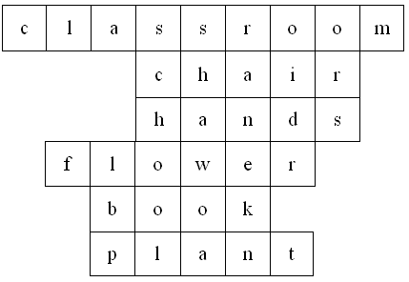

I worked …….

(hard, like a bee, like a dragonfly)

because ………….



1. …..I wantto get a good wark.
2. ….. It is interesting for me.
3. ….. I want to know English.
4. ….. It is difficult for me.
5. ….. I want to go to London.

b) Do you like our lesson?

P. Yes.

T. It you like our lesson, show me the red face.



If you don, t like our lesson, show me the yellow

If our lesson was boring and uninteresting show me the green face.